**Lake Mead**

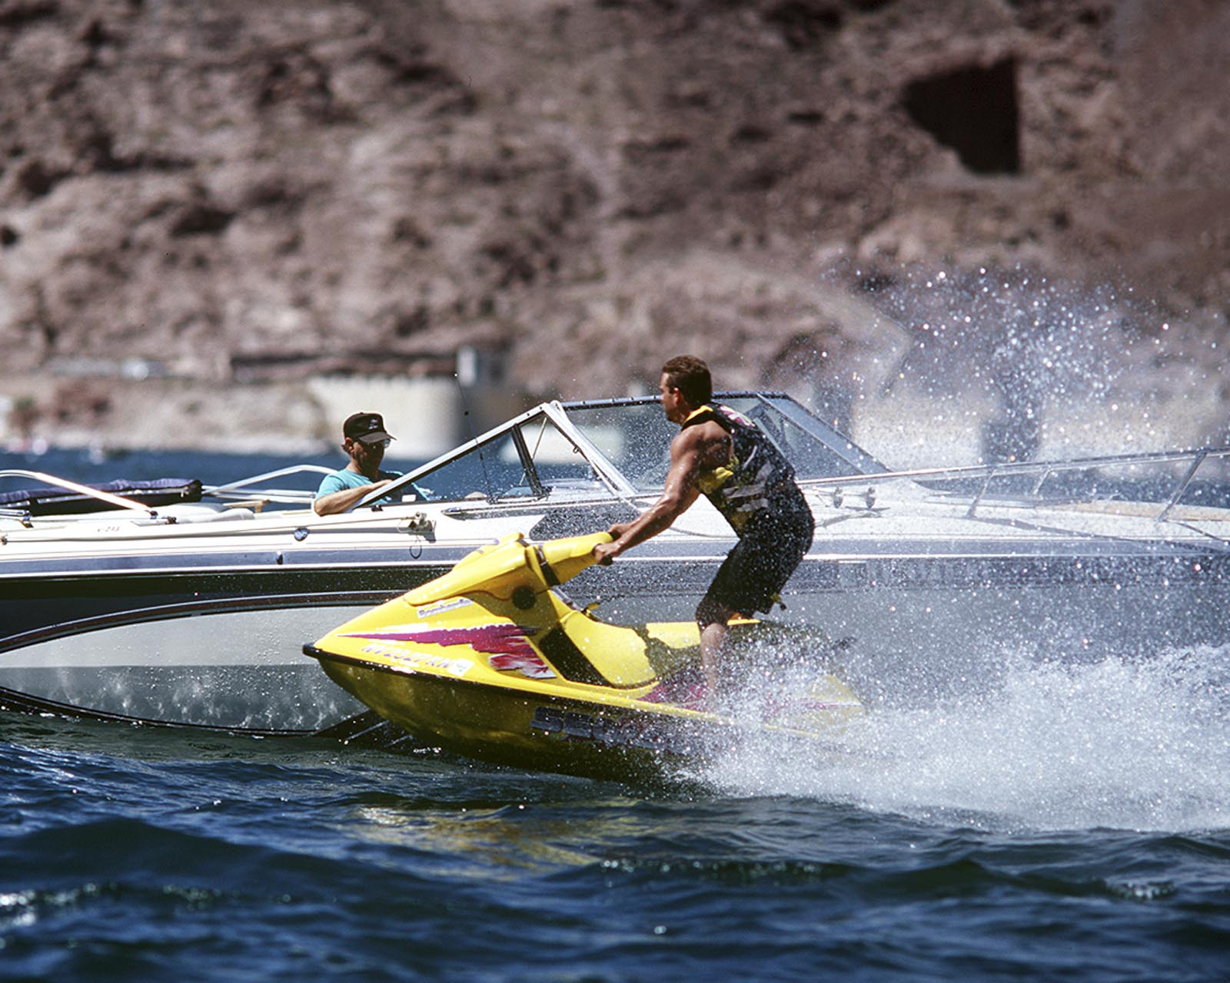

Recreation, although a by-product of Hoover Dam's reservoir, constitutes a major use of Lake Mead and the lands surrounding it.

Lake Mead is one of America's most popular recreation areas, with a 12-month season that attracts more than 9 million visitors each year for swimming, boating, skiing, fishing and other outdoor pursuits.

The lake and surrounding area are administered by the National Park Service as part of [Lake Mead National Recreation Area](http://www.nps.gov/lame), the nation's first national recreation area, which also includes Lake Mohave downstream from Hoover Dam.

**What is the lake's elevation at high-water?**

The high-water line is at 1,229 feet above sea level. At this elevation, the water would be more than 7 1/2 feet over the top of the raised spillway gates, which are at elevation 1,221.4 feet. All lands below elevation 1,250 have been retained for reservoir operations purposes.

**What is the reservoir's area?**

At elevation 1,221.4 feet the reservoir covers about 157,900 acres or 247 square miles.

**How long and wide is the reservoir?**

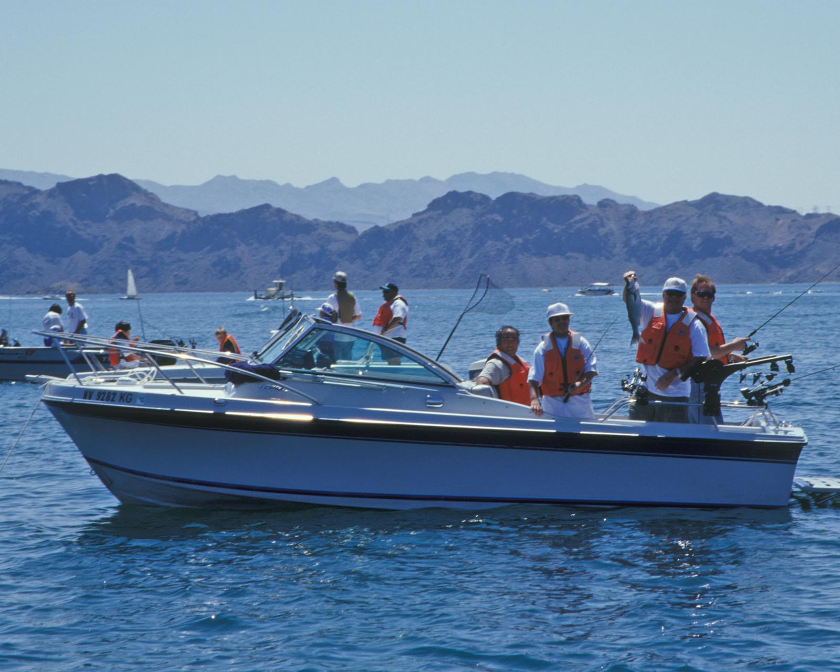

At elevation 1,221.4, Lake Mead extends approximately 110 miles upstream toward the Grand Canyon. It also extends about 35 miles up the Virgin River. The width varies from several hundred feet in the canyons to a maximum of eight miles.

**How much water will Lake Mead hold?**

At elevation 1,221.4, it would contain 28,537,000 acre-feet. An acre-foot is the amount of water required to cover one acre to a depth of one foot, or approximately 326,000 gallons. The reservoir will store the entire average flow of the Colorado River for two years. That is enough water to cover the State of Pennsylvania to a depth of one foot.

**How is the reservoir capacity allotted?**

Below elevation 1,229, about 1,500,000 acre-feet of storage capacity is reserved exclusively for flood control; about 2,378,000 acre-feet for sedimentation control; about 15,853,000 acre-feet for joint use (flood control, municipal and industrial water supply, irrigation and power); and 10,024,000 acre-feet for inactive storage.

**Who operates the dam and reservoir?**

The Bureau of Reclamation operates and maintains the dam, powerplant and reservoir. The National Park Service administers recreational activities in and around Lake Mead as part of Lake Mead National Recreation Area.

**How much sediment will be deposited in the reservoir?**

Between 1935 and 1963, about 91,000 acre-feet of sediment was deposited in Lake Mead each year. With the installation of Glen Canyon Dam, about 370 miles upstream, the life of Lake Mead is indefinite.

**What is the estimated annual evaporation of the reservoir?**

About 800,000 acre-feet each year.

Last Reviewed: December 2008